**Steps Followed - Book Detail Template Implementation**

This document outlines the step-by-step approach taken to implement the **Book Detail Template**, including navigation, footer, multi-field component usage, and styling from ui.frontend.

**Step 1: Creating the Book Detail Template**

1. Designed a **template layout** for book details.
2. Included the following fields in the template:
   * **Book Title**
   * **Cover Image**
   * **Author Name**
   * **Short Description**

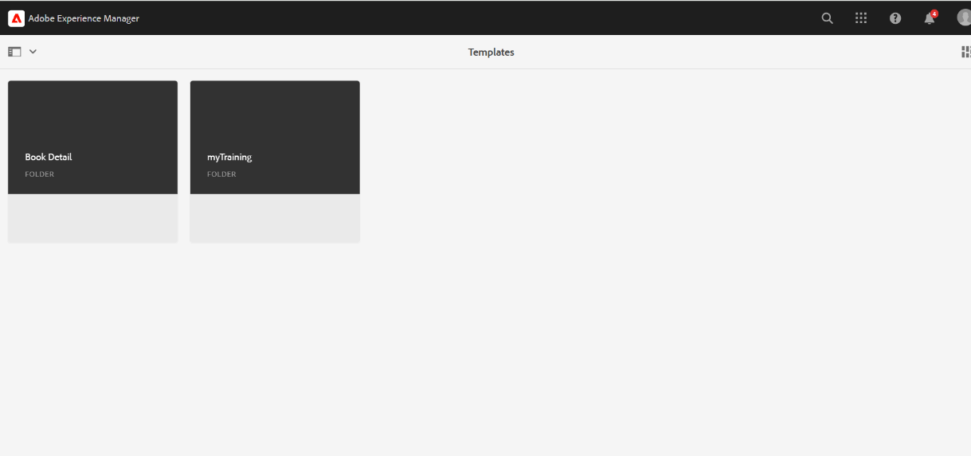



**Step 2: Creating 10 Unique Book Pages**

1. Created **10 pages**, each having a **unique name and URL**.
2. Used the **multi-field component** to enter book details dynamically.
3. Ensured **each page followed the same structured template**

**Step 3: Implementing the Header & Navigation**

1. Created a **Header Component** that contains:
   * **Logo** on the left.
   * **Navigation Links** for:
     + Books
     + About Me
     + Reach Me
2. Implemented the **Navigation Component** inside the Header.
3. Applied **styling from ui.frontend** for a uniform design.
4. Ensured the **header remains fixed and responsive**.

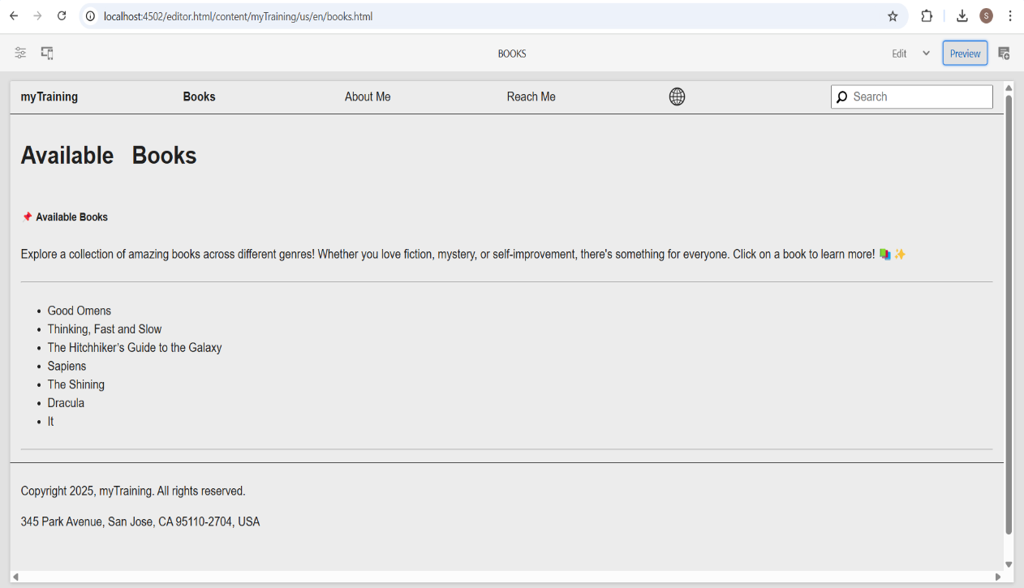

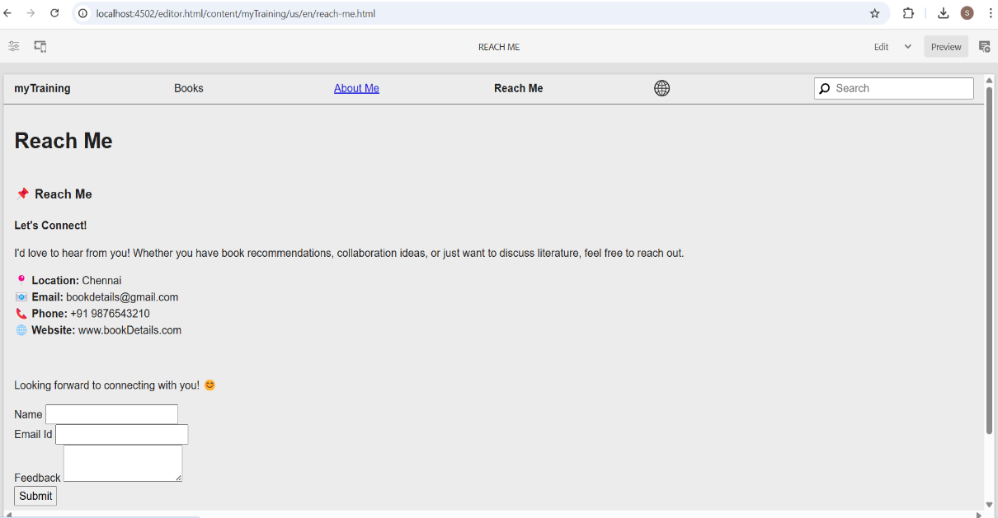

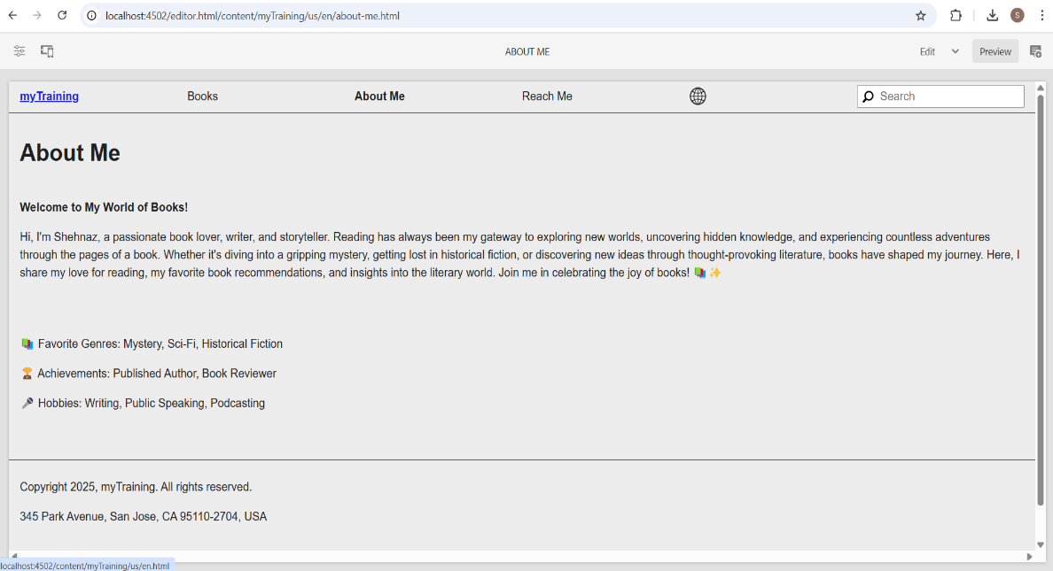

**Step 4: Implementing the Multi-Field Component**

1. Created a **multi-field component** to store **book details dynamically**.
2. The component includes fields for:
   * Book Title
   * Author
   * Cover Image
   * Description
3. Ensured the **component is reusable** across multiple book pages.

